Bank API Integration
# Source: AI Source: Provided by: [Data Path: Persons Table -> ID Column: 1, Name_En Column: Motasem Essam] -> From: [Chatgpt (GPT‑5 Mini)] on [1/21/2026]
Bank API Integration is the part of your system that enables direct communication with a bank’s payment infrastructure. It lets your app initiate payments, check payment status, handle refunds, and sometimes even authenticate transactions — all through HTTP-based APIs provided by the bank.

📦 Purpose of Bank API Integration
# Source: AI Source: Provided by: [Data Path: Persons Table -> ID Column: 1, Name_En Column: Motasem Essam] -> From: [Chatgpt (GPT‑5 Mini)] on [1/21/2026]
To allow your app to:
- Send secure payment requests to the bank
- Retrieve real-time transaction statuses
- Handle refunds or cancellations
- Receive automated callbacks (webhooks)
- Integrate with optional services (e.g., 3D Secure, tokenization, installments)

🔧 Typical Bank API Functions
# Source: AI Source: Provided by: [Data Path: Persons Table -> ID Column: 1, Name_En Column: Motasem Essam] -> From: [Chatgpt (GPT‑5 Mini)] on [1/21/2026]
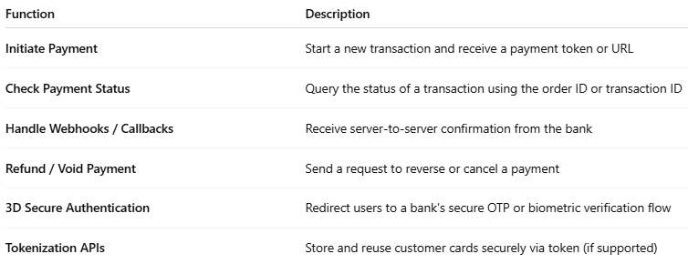

Function | Description
Initiate Payment | Start a new transaction and receive a payment token or URL
Check Payment Status | Query the status of a transaction using the order ID or transaction ID
Handle Webhooks / Callbacks | Receive server-to-server confirmation from the bank
Refund / Void Payment | Send a request to reverse or cancel a payment
3D Secure Authentication | Redirect users to a bank's secure OTP or biometric verification flow
Tokenization APIs | Store and reuse customer cards securely via token (if supported)

🔐 Security in Bank API Integration
# Source: AI Source: Provided by: [Data Path: Persons Table -> ID Column: 1, Name_En Column: Motasem Essam] -> From: [Chatgpt (GPT‑5 Mini)] on [1/21/2026]
- API Authentication:
  - Banks usually use API keys, OAuth 2.0, or HMAC signatures to verify requests.
- HTTPS Only:
  - All requests must be made over secure SSL/TLS connections.
- Signature Verification:
  - For incoming webhooks/callbacks, you must validate the message with a shared secret or digital signature.

🧱 Example API Integration Flow

1. Initiate Payment
# Source: AI Source: Provided by: [Data Path: Persons Table -> ID Column: 1, Name_En Column: Motasem Essam] -> From: [Chatgpt (GPT‑5 Mini)] on [1/21/2026]
Send POST request to the bank’s API:
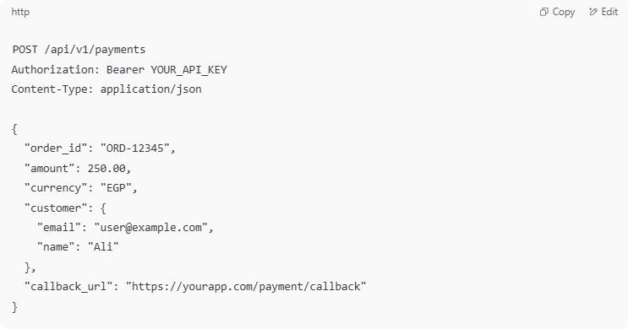
POST /api/v1/payments
Authorization: Bearer YOUR_API_KEY
Content-Type: application/json

{
"order_id": "ORD-12345",
"amount": 250.00,
"currency": "EGP",
"customer": {
"email": "user@example.com",
"name": "Ali"
},
"callback_url": "https://yourapp.com/payment/callback"
}

2. Redirect for OTP (if required)
# Source: AI Source: Provided by: [Data Path: Persons Table -> ID Column: 1, Name_En Column: Motasem Essam] -> From: [Chatgpt (GPT‑5 Mini)] on [1/21/2026]
- If the bank uses 3D Secure, you'll get a redirect URL in response.
- Redirect the customer to complete OTP verification.

3. Receive Callback (Webhook)
# Source: AI Source: Provided by: [Data Path: Persons Table -> ID Column: 1, Name_En Column: Motasem Essam] -> From: [Chatgpt (GPT‑5 Mini)] on [1/21/2026]
The bank sends a payment status to your server:
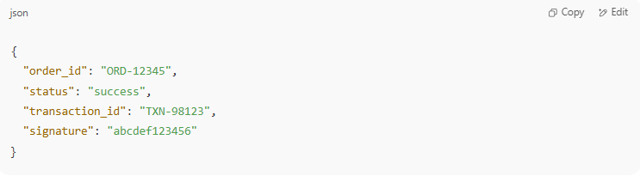
{
"order_id": "ORD-12345",
"status": "success",
"transaction_id": "TXN-98123",
"signature": "abcdef123456"
}

Validate the signature and update your system accordingly.

4. Verify Transaction (Optional but Recommended)
# Source: AI Source: Provided by: [Data Path: Persons Table -> ID Column: 1, Name_En Column: Motasem Essam] -> From: [Chatgpt (GPT‑5 Mini)] on [1/21/2026]
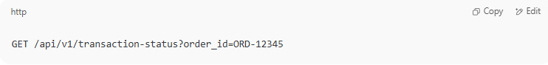
GET /api/v1/transaction-status?order_id=ORD-12345

Cross-check with your own database.

✅ Best Practices for Bank API Integration
# Source: AI Source: Provided by: [Data Path: Persons Table -> ID Column: 1, Name_En Column: Motasem Essam] -> From: [Chatgpt (GPT‑5 Mini)] on [1/21/2026]
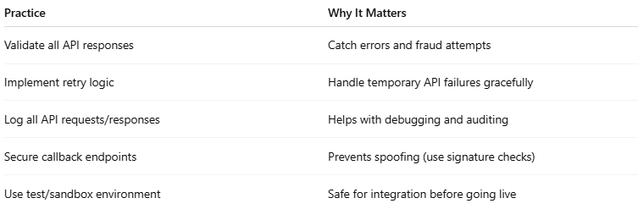
Practice | Why It Matters
Validate all API responses | Catch errors and fraud attempts
Implement retry logic | Handle temporary API failures gracefully
Log all API requests/responses | Helps with debugging and auditing
Secure callback endpoints | Prevents spoofing (use signature checks)
Use test/sandbox environment | Safe for integration before going live

🔍 Common Challenges
# Source: AI Source: Provided by: [Data Path: Persons Table -> ID Column: 1, Name_En Column: Motasem Essam] -> From: [Chatgpt (GPT‑5 Mini)] on [1/21/2026]
- Bank APIs are often less standardized than services like Stripe.
- Documentation may be limited or require direct support from the bank.
- May require manual approval or onboarding before API access.

🧠 Summary
# Source: AI Source: Provided by: [Data Path: Persons Table -> ID Column: 1, Name_En Column: Motasem Essam] -> From: [Chatgpt (GPT‑5 Mini)] on [1/21/2026]
Bank API Integration is the technical link between your app and the bank. You build it to:
- Send payment requests
- Receive updates
- Manage the full lifecycle of each transaction

